Practical-3

# Aim-1: Write a script called hello which outputs the following:

* **your username**

# the time and date

* **who is logged on**

# Also output a line of asterisks (*********) after each section.

**Code:**

echo "***************************************************" echo "User: $USER"

echo "***************************************************" echo "Date & Time: `date`"

echo "***************************************************" echo "Logged User: $LOGNAME "

echo "***************************************************" echo "20DCE019-Yatharth chauhan"

echo "***************************************************"

**Output:**

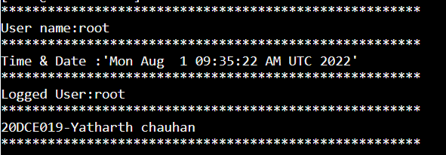

**Aim-2: Write a shell script which calculates nth Fibonacci number where n will be provided as input when prompted.**

**Code:**

printf "Enter a Number :" read N

a=0 b=1

echo "Fibonacci series :" for((i=0;i<=N;i++))

do

echo "$a" fn=$((a+b)) a=$b

b=$fn done

echo "**************************" echo "20DCE019-Yatharth chauhan" echo "**************************"

**Output:**

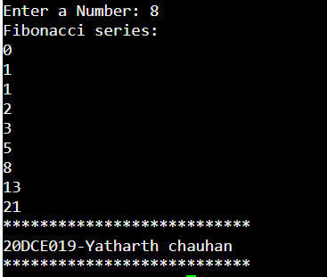

**Aim-3: Write a shell script which takes one number from user and finds factorial of a Given number.**

**Code:**

printf "Enter a Number :" read N

fact=1 for((i=1;i<=N;i++)) do

fact=$((fact*i)) done

echo "Factorial of $N is $fact"

echo "************************************" echo "20DCE019-Yatharth chauhan"

echo "************************************"

**Output:**

